# 1.One-way Binding

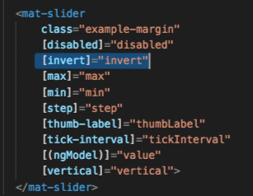

mat-slider 's attribute invert(inside the []), bind to invert(inside the ());

Mat-checkbox's value attribute is bind to invert,(two-way binding here)

So, the when the value of mat-checkbox changes, it changes the value of the [invert] attribute in matslider.

*value of invert is boolean value(true/false).

# 2.Two-way Binding

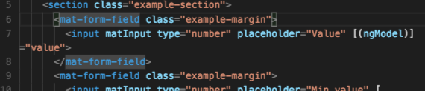

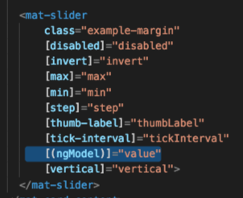

Before this, take a look at how ngModel works:

ngModel is a selector which will be available with FormControl Instance

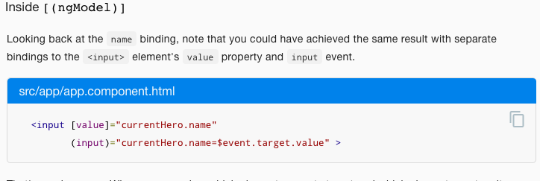

[attribute], set html value property

(event), change html value property when event happens

It accepts a domain model as an optional [Input](https://angular.io/api/core/Input). If you have a one-way binding to [ngModel](https://angular.io/api/forms/NgModel) with [] syntax, changing the value of the domain model in the component class will set the value in the view. If you have a two-way binding with [()] syntax (also known as 'banana-box syntax'), the value in the UI will always be synced back to the domain model in your class as well.

# There is other two-way bing selector:

For example, 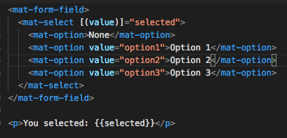

The <mat-select> supports 2-way binding to the value property without the need for Angular forms.